Personality Article
Student’s Name
Institutional Affiliation

Personality Article
Bio concept that matches the template
Based on my personality, I am an outgoing person who enjoys the company of my fellow students, where we brainstorm on different life perspectives. We recently spend our leisure having a nature walk.
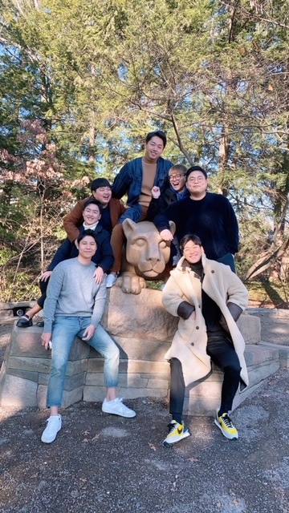
Relationship management personality character means having the capability to manage a relationship with people. On the hiking incident, one of my main objectives was to learn my friends' personalities as well as knowing areas that needed improvement. The aspect of building relationships and seeing the positive aspect of people defines me. Furthermore, this personality trait makes me relate well with fellow students (Frost, 2020). Based on this aspect, I may consider myself fortunate enough since I can provide alternatives for better relations among people. My personality trait does not only focus on my relationship aspects with my friends but also valuable advice, which proves useful. Furthermore, I am well-versed in negotiations, and this aspect makes me suitable. I job market where my personality may be necessary for carrying out negotiations for any business firm.
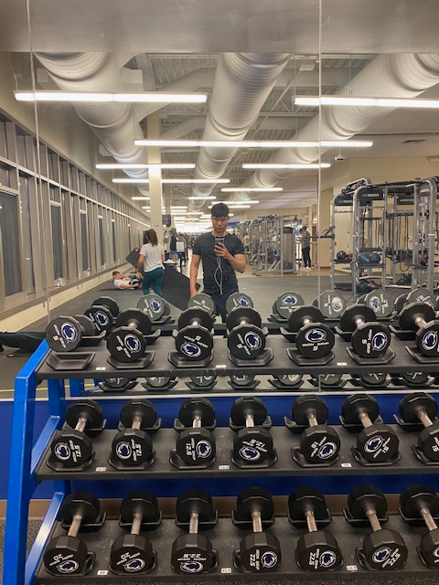
Additionally, my personality trait has made me discover my personal capabilities, which were not evident initially. I work better when solving already existing problems. The problem solved concerns my friends, my schoolmates or my family as well. Since the aspect of building relationships is, and negotiating are part of my personality, people do not always notice when I am providing solutions to their problems (Frost, 2020). Still, in the end, all things turn out as anticipated. The more I help people, the more I am challenged to support a wider group of people. Consequently, the more I understand how to solve people's relationship constrains, the more I am determined to find more solutions as well as those that apply to everyone.
My future plan to sharpen my personality traits
One of my plans that I am still working towards is volunteering in helping more people build relationships with their friends and their families. Additionally, I have been holding negotiations on behalf of my friend on some of the things that matter to them most, for example, negotiating with the gym instructor. On this occasion of consulting with the gym instructor, my friends wanted special lessons with the gym instructor, but they did not know the most suitable approach to this situation. Since my personality trait provides for negotiating skills, I volunteered and agreed with the gym instructor on policies that were suitable for both parties. Through this negotiating aspect, I also achieved the objective of building people's relationships where there was a significant-good relationship between the gym instructor and my friends.
The things I do to see other people succeed keeps me going. My ability and self-confidence are boosted when I successfully negotiate and provide relationship solutions. Based on this aspect, the question that lingers in my mind is where will I be in 5-10 years from now? I picture myself as a successful negotiator of business firms or even a diplomat in our country. Through taking these roles, I would have made an impact not only in my life but also in the life of others in a positive way. One of Ben Franklin's quotes is writing something worth reading or doing something excellent worth writing, and through my article, I effectively utilize the meaning of the quote (Patel, 2020).

Reference
Frost, A. (2020). 5 LinkedIn Summary Templates That'll Make Writing Yours a Breeze. Retrieved 21 April 2020, from https://www.themuse.com/advice/5-templates-thatll-make-writing-the-perfect-linkedin-summary-a-breeze
Patel, S. (2020). Usually somewhere between hanging out and hanging on ​. Retrieved 21 April 2020, from https://www.sarikapatel.com/

